Name : K Jahnavi
Reg no: 192512169
Ex No 8 : Steering Angle Variation in MIMO Beamforming Using MATLAB
Aim
To analyze the effect of steering angle variation in a MIMO beamforming system by studying steering angle, array gain, and beam direction error using MATLAB.
Objectives
1. To analyze the steering angle of a MIMO beamforming system by directing the beam towards different target directions using MATLAB.
2. To compare the array gain achieved for different steering angles in a MIMO beamforming system using MATLAB.
3. To evaluate the beam direction error between the desired steering angle and the actual beam direction using MATLAB.
Procedure:
clc;
clear;
close all;
angle = [-60 -30 0 30 60]; % Steering Angles (degrees)
gain = ones(size(angle)); % Normalized Gain
figure
polarplot(deg2rad(angle), gain,'o-','LineWidth',2)
title('Steering Angle Variation in MIMO Beamforming')

Output:
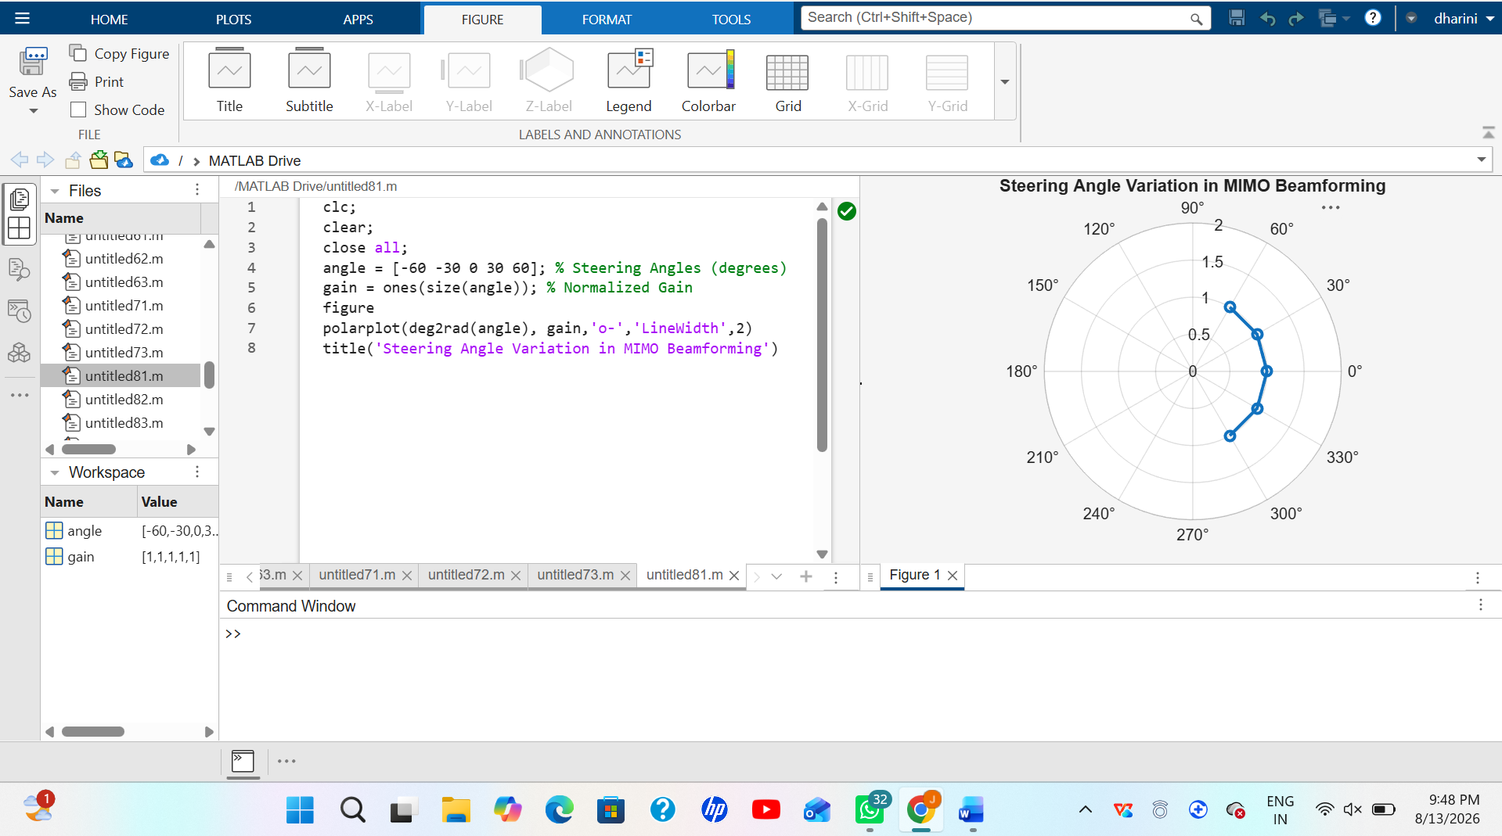
Objective 2:
clc;
clear;
close all;
angle = [-60 -30 0 30 60]; % Steering Angles (degrees)
gain = [9 12 15 12 9]; % Array Gain (dB)
figure
bar(angle, gain)
grid on
xlabel('Steering Angle (Degrees)')
ylabel('Array Gain (dB)')
title('Array Gain for Different Steering Angles')

Output:
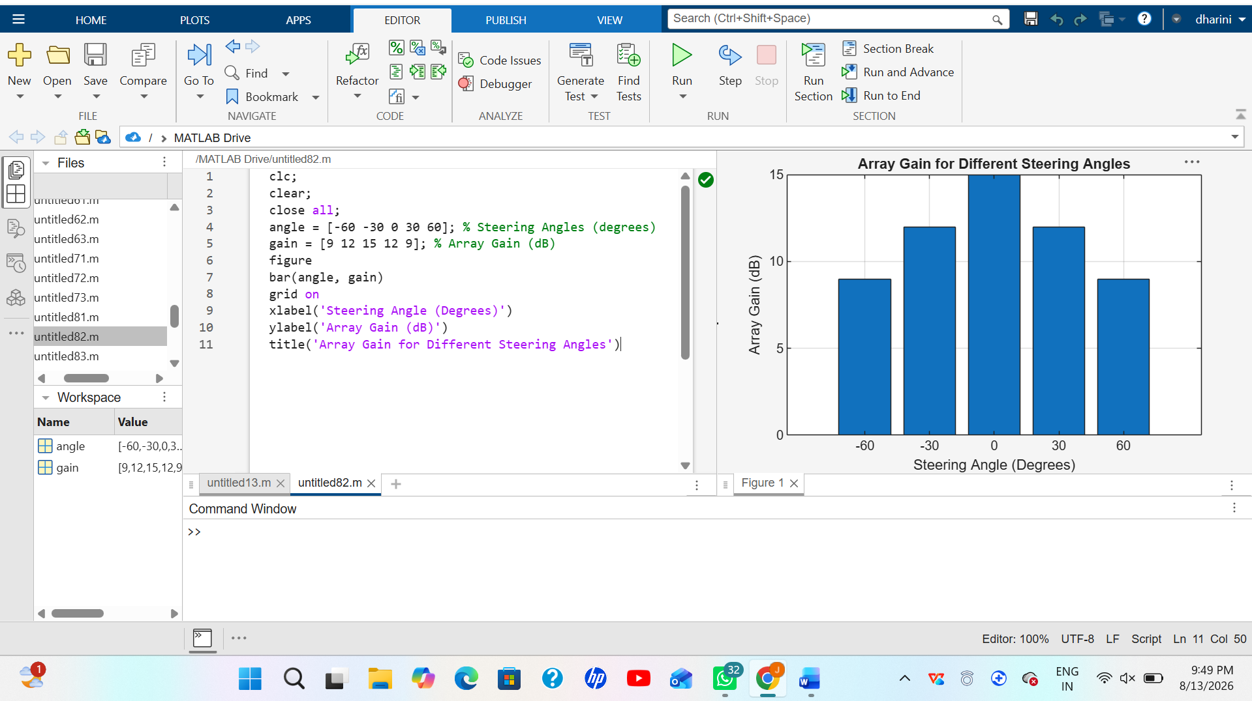
Objective 3:
clc;
clear;
close all;
desired = [-60 -30 0 30 60]; % Desired Steering Angle (degrees)
actual = [-58 -32 1 29 62]; % Actual Beam Direction (degrees)
error = abs(desired - actual); % Beam Direction Error
figure
plot(desired, error, 'o-', 'LineWidth', 2)
grid on
xlabel('Desired Steering Angle (Degrees)')
ylabel('Beam Direction Error (Degrees)')
title('Beam Direction Error for Different Steering Angles')

Output:
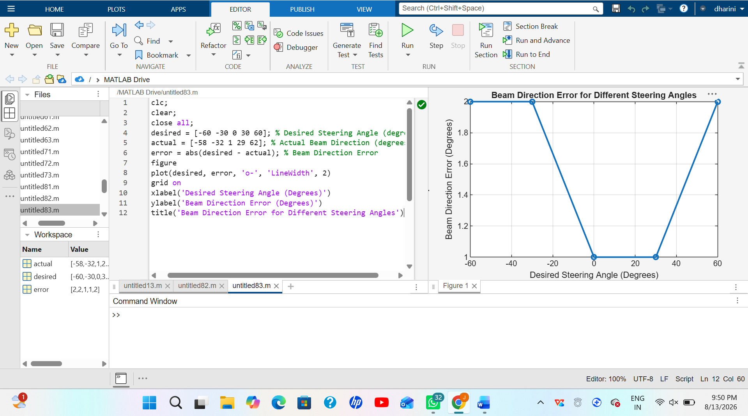
Result
The MATLAB analysis successfully demonstrated steering angle variation in a MIMO beamforming system. The results showed that beam steering effectively directs the transmitted energy toward different angles, while maintaining high array gain and minimizing beam direction error.

